**Practical No. 7**

**Aim:** Implement and manage the network of VMware ESXi server

1. **Create vSphere Standard switch**

The vSphere Standard Switch is a simple virtual switch configured and managed at the host level. This switch provides access, traffic aggregation, and fault tolerance by allowing multiple physical adapters to be bound to each virtual switch.

Adding and configuring vSphere standard switch.

Go to the browser and paste the labs.hol.vmware/hol/catalog content and first link to open then show screen like below image

If you are not already logged in, launch the Chrome browser from the desktop and log in to the vSphere Web Client.

Enroll the Virtualization 101(HOL-2210-01-SDC)

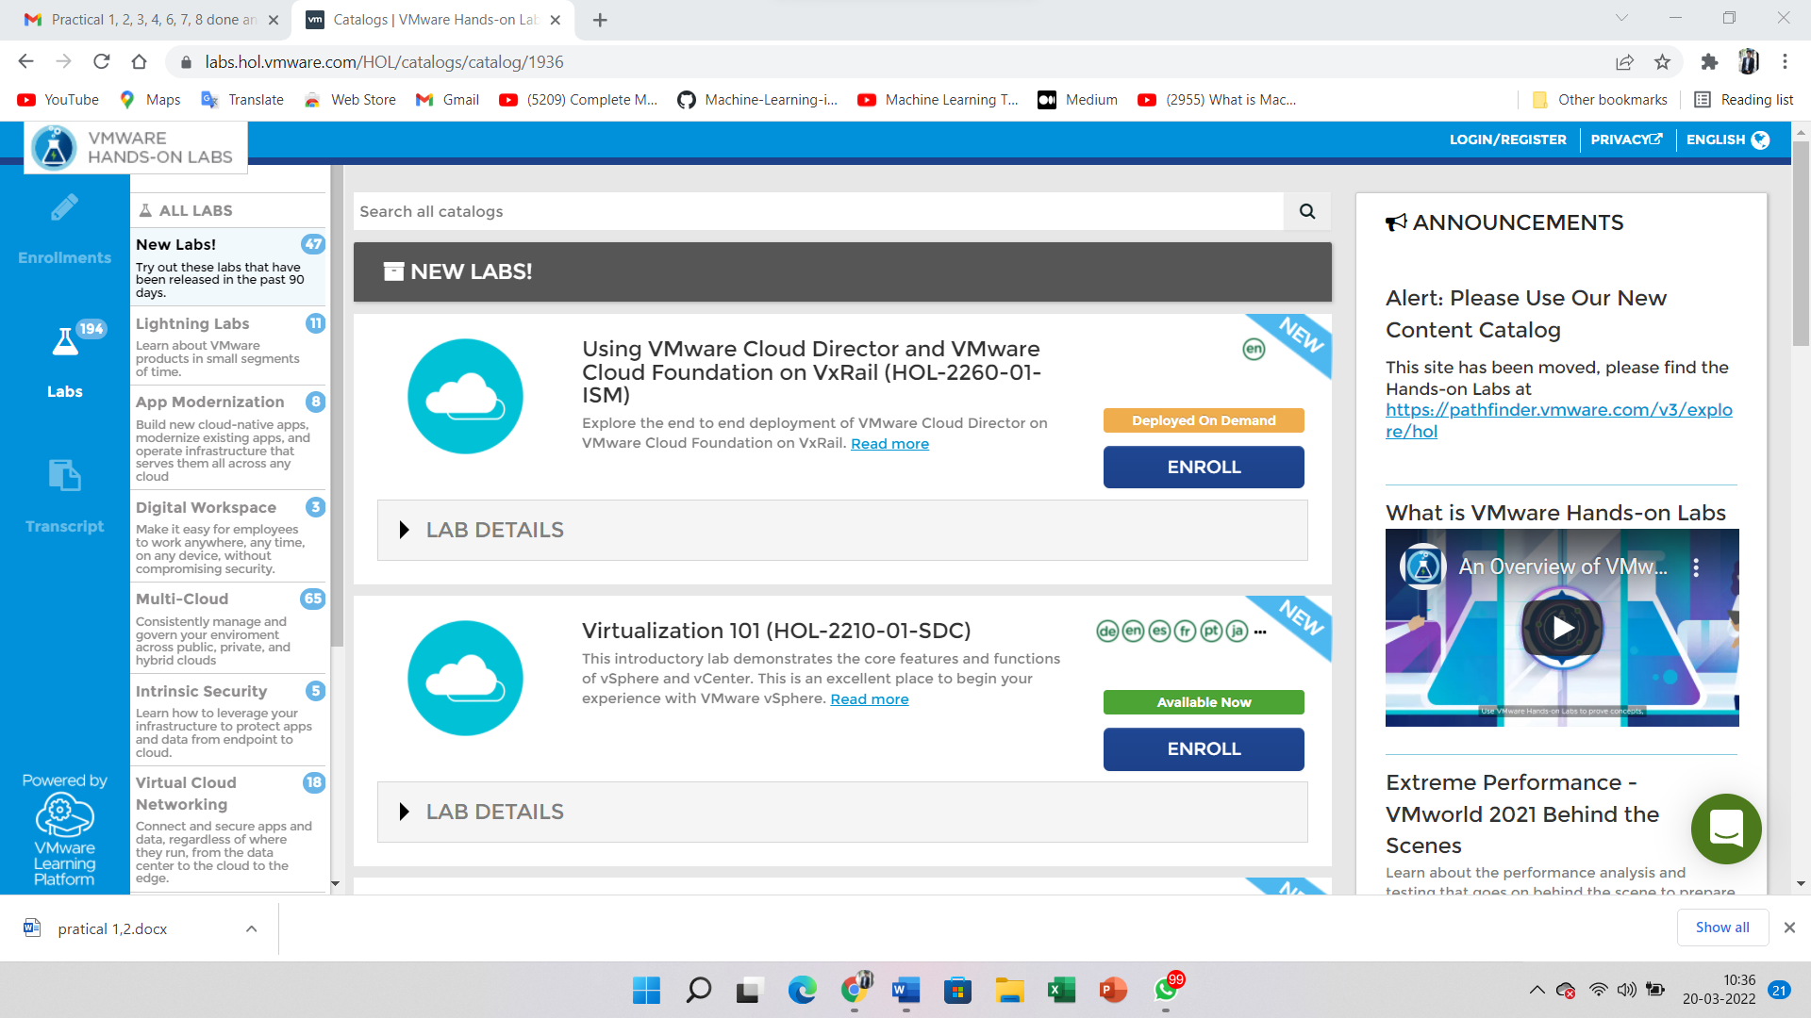

Start the Lab

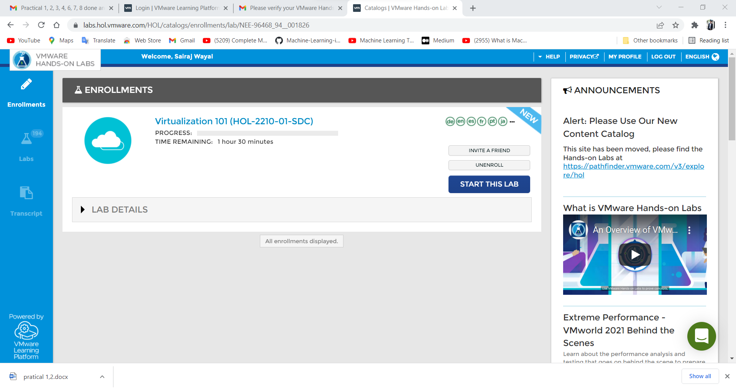

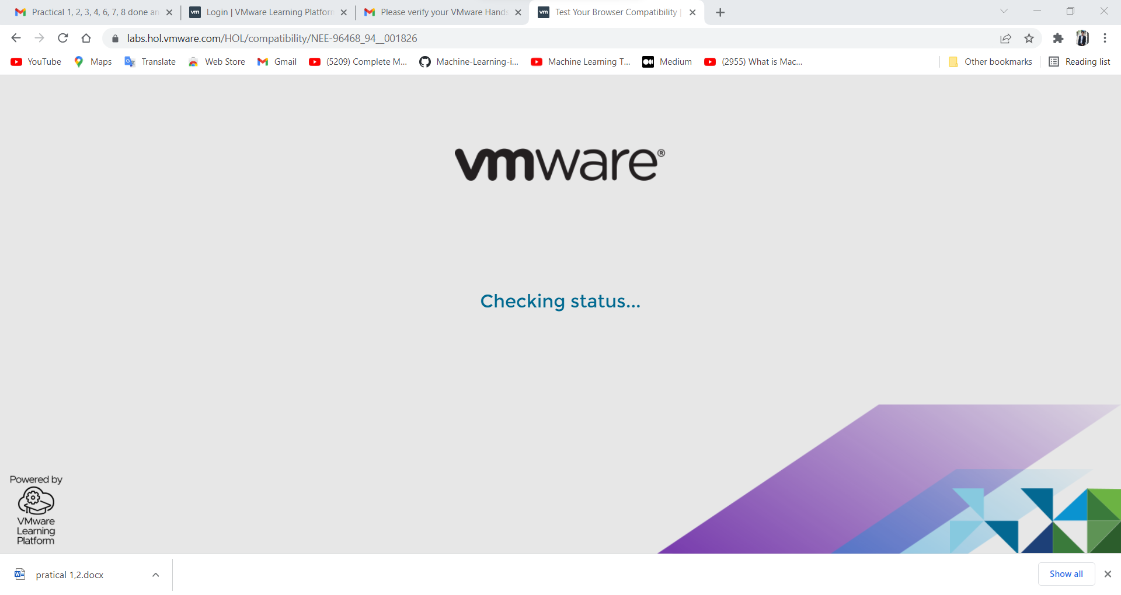

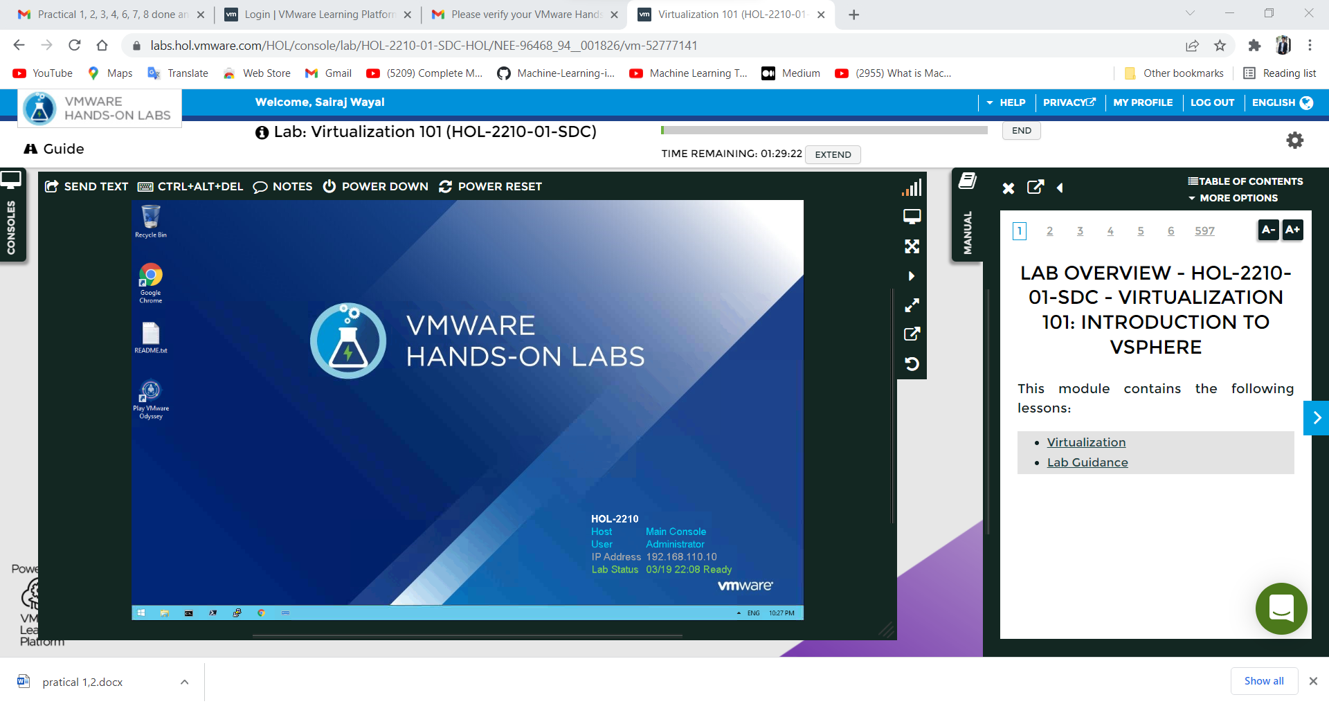

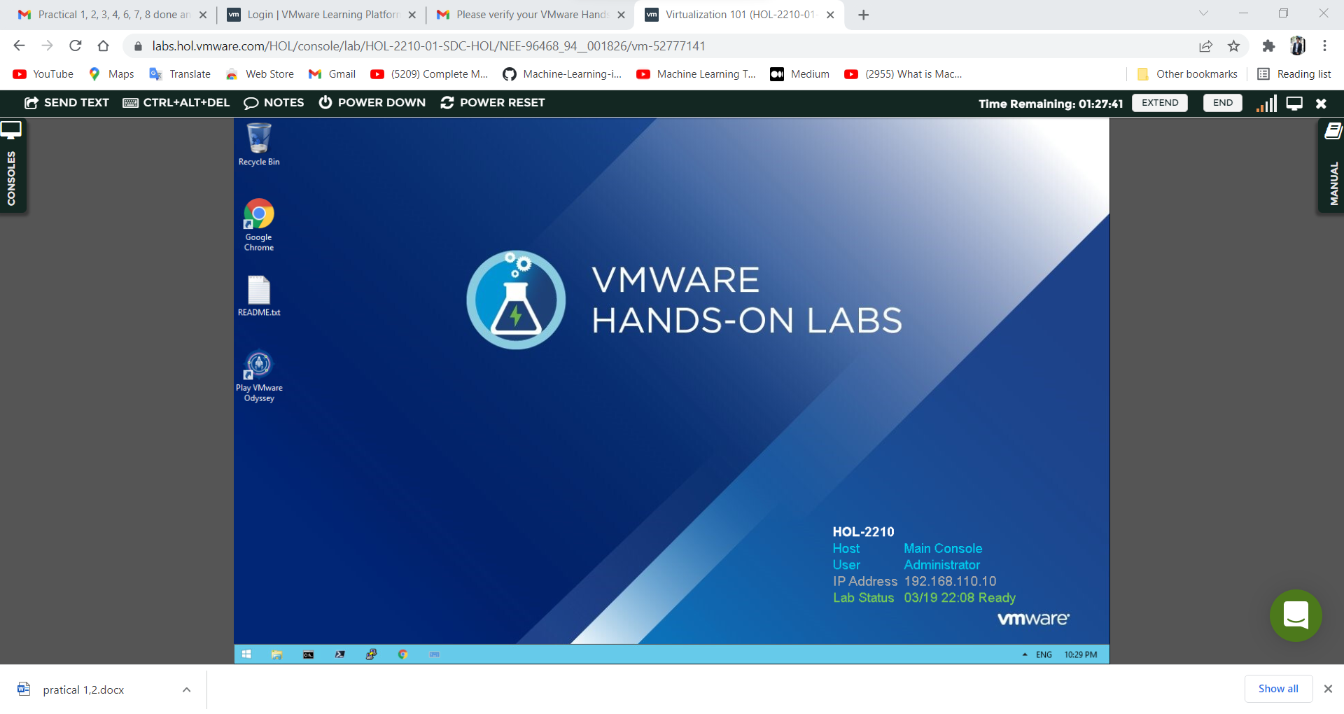

Then select host and clusters.

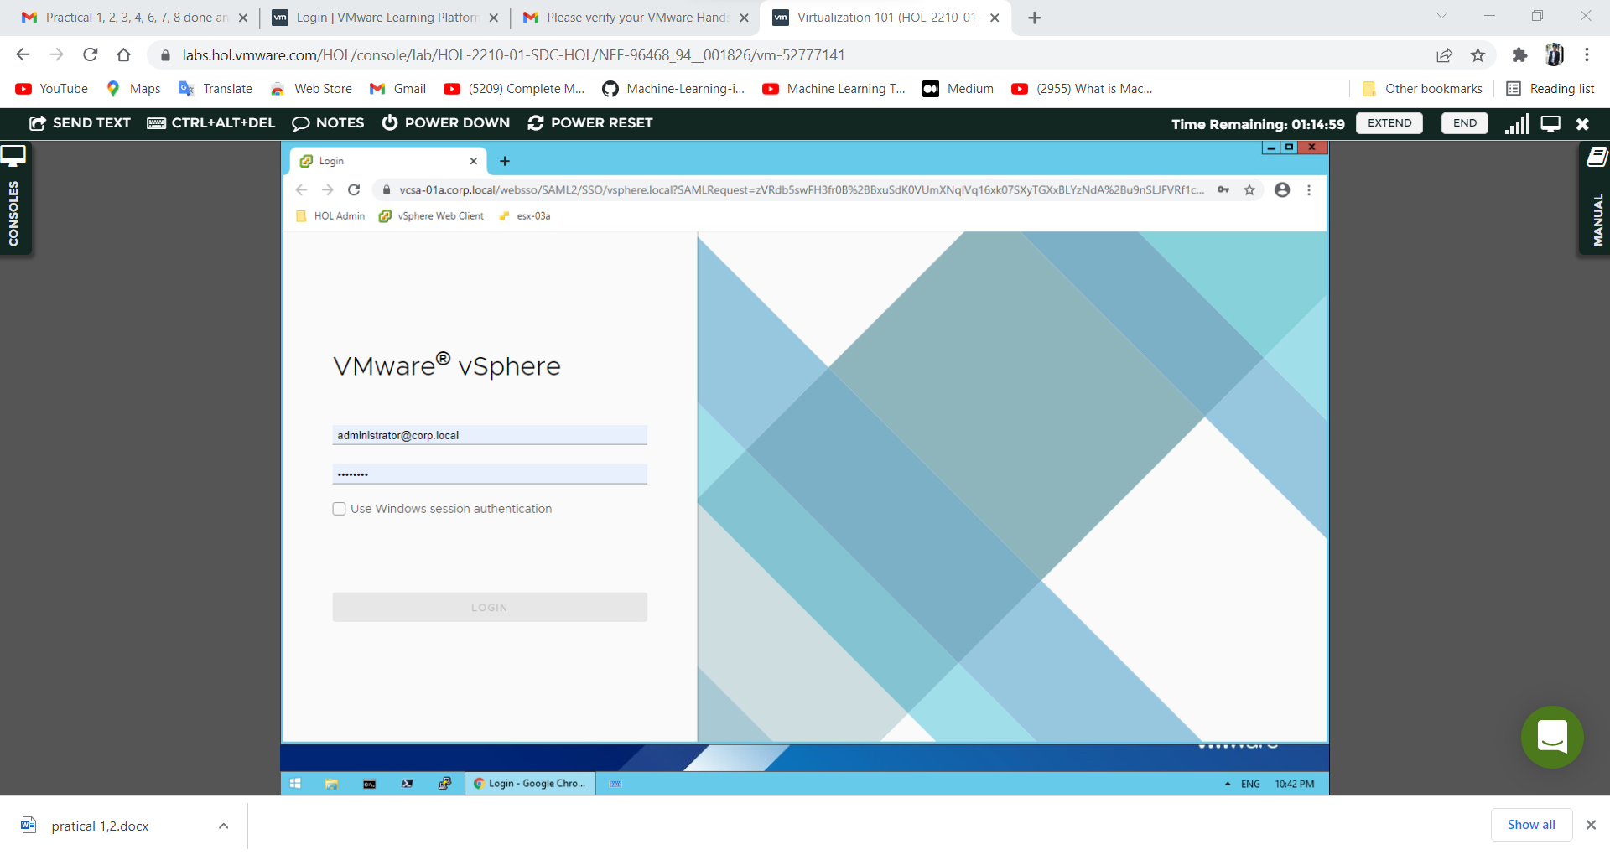

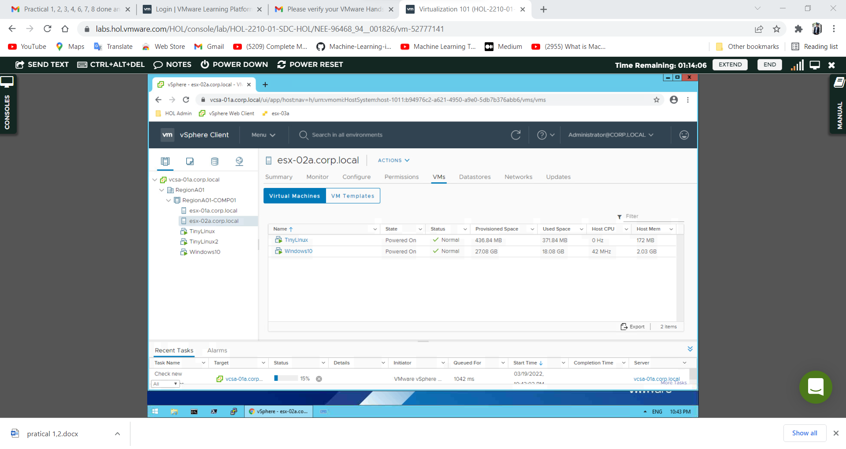

Under **vcsa-01a.corp.local**, expand **RegionA01** and then **RegionA01-COMP01**. Next**, right-click** **on esx-02a.corp.local** in the Navigator. Select **Add Networking**…

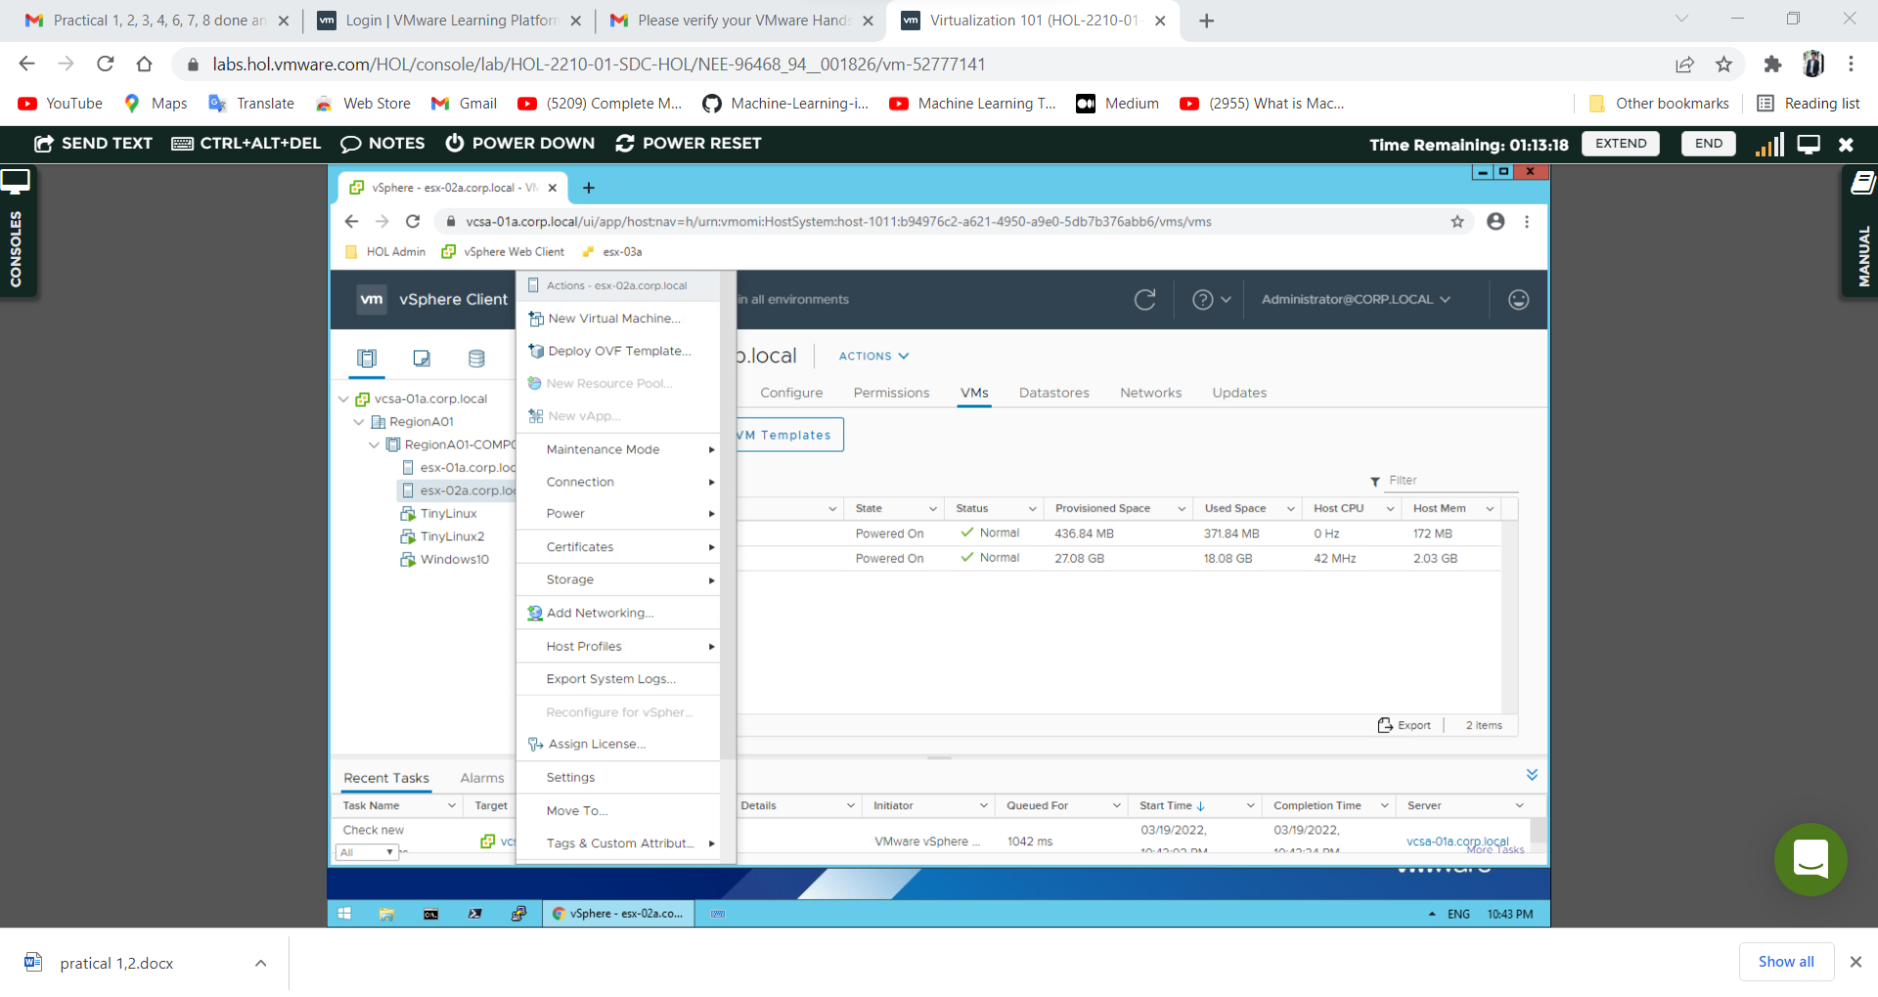

When asked to select the **connection type**, choose **Virtual Machine Port Group for a Standard Switch** & Click **Next**.

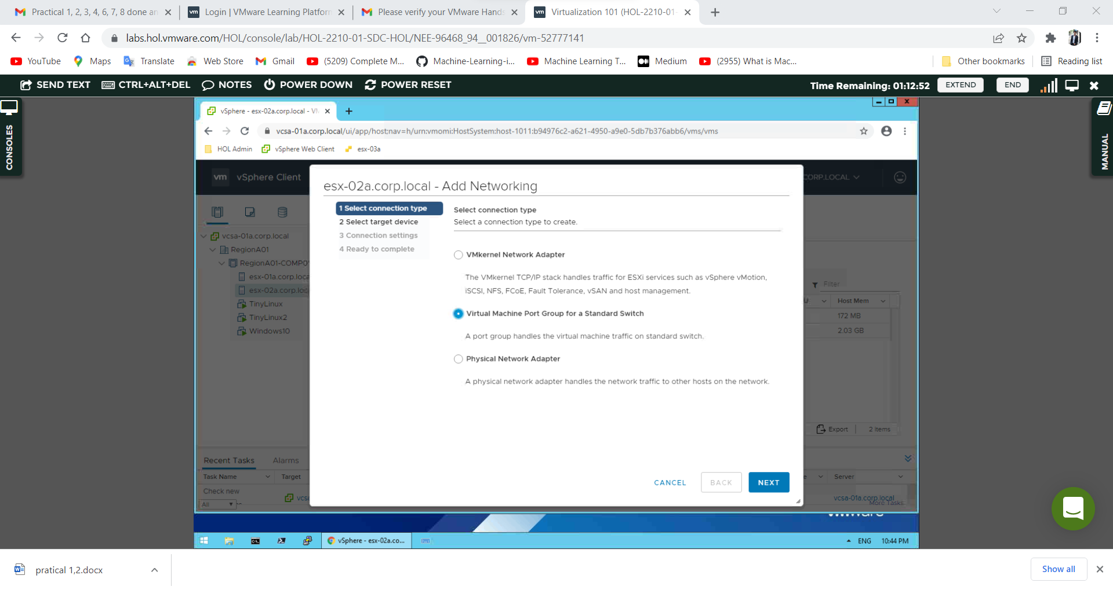

When asked to **select a target device**, choose **New Standard Switch**. Note that a larger **MTU size** can be specified if **needed** & Click **Next**.

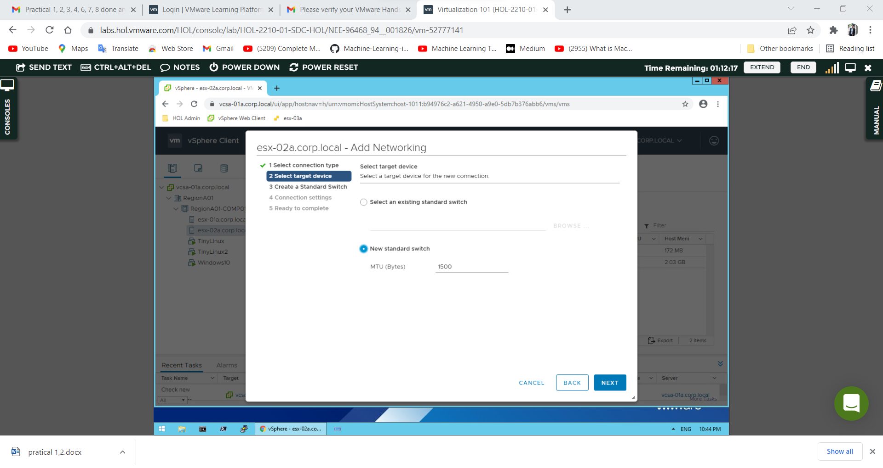

Click the '**+**’ button.

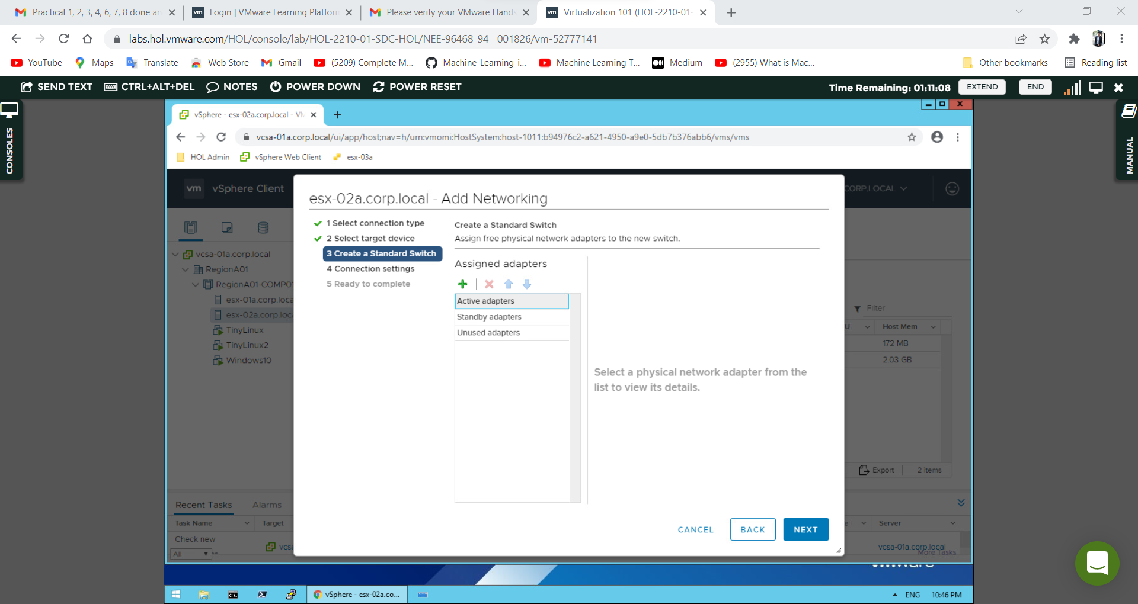

Select **vmnic3** under **Network Adapters** & Click **OK**. After Click **Next** to continue.

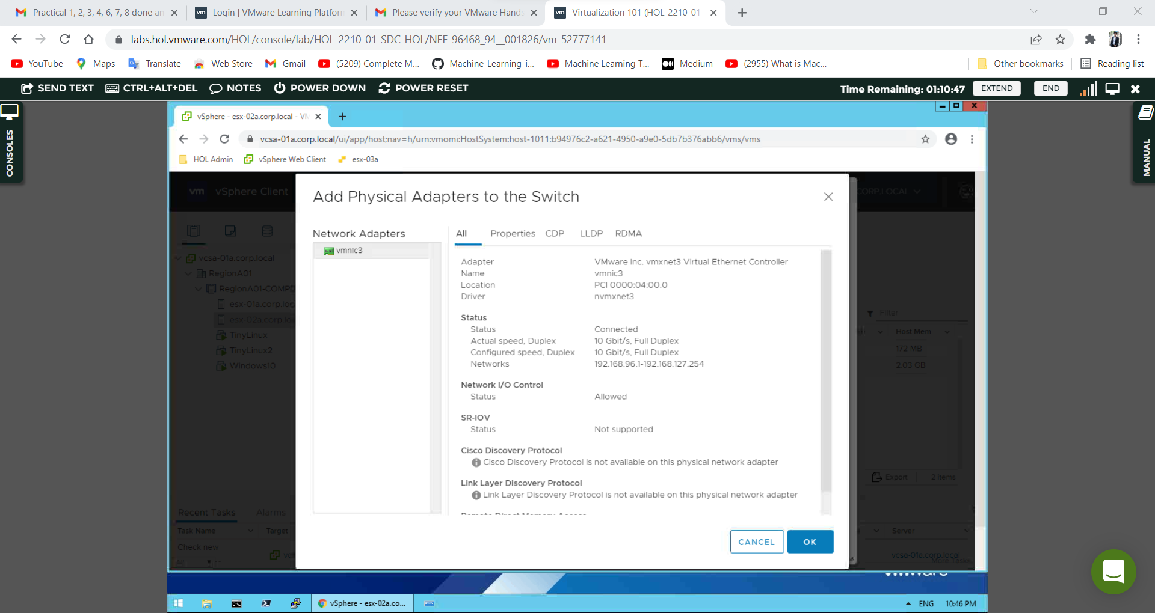

At the Connection settings step of the wizard, for the **Network label**, leave the default name of VM Network 2. **Do not change the VLAN ID**; leave this set to None (0).:

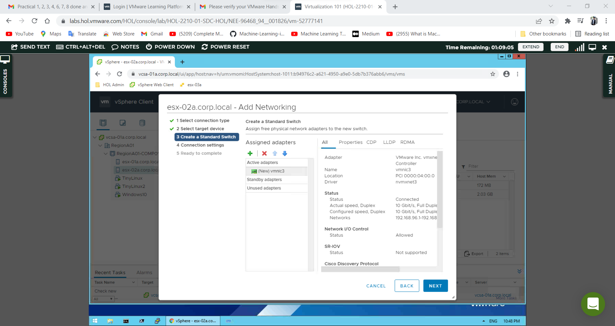

Review the port group settings in Ready to complete and click **Finish**.

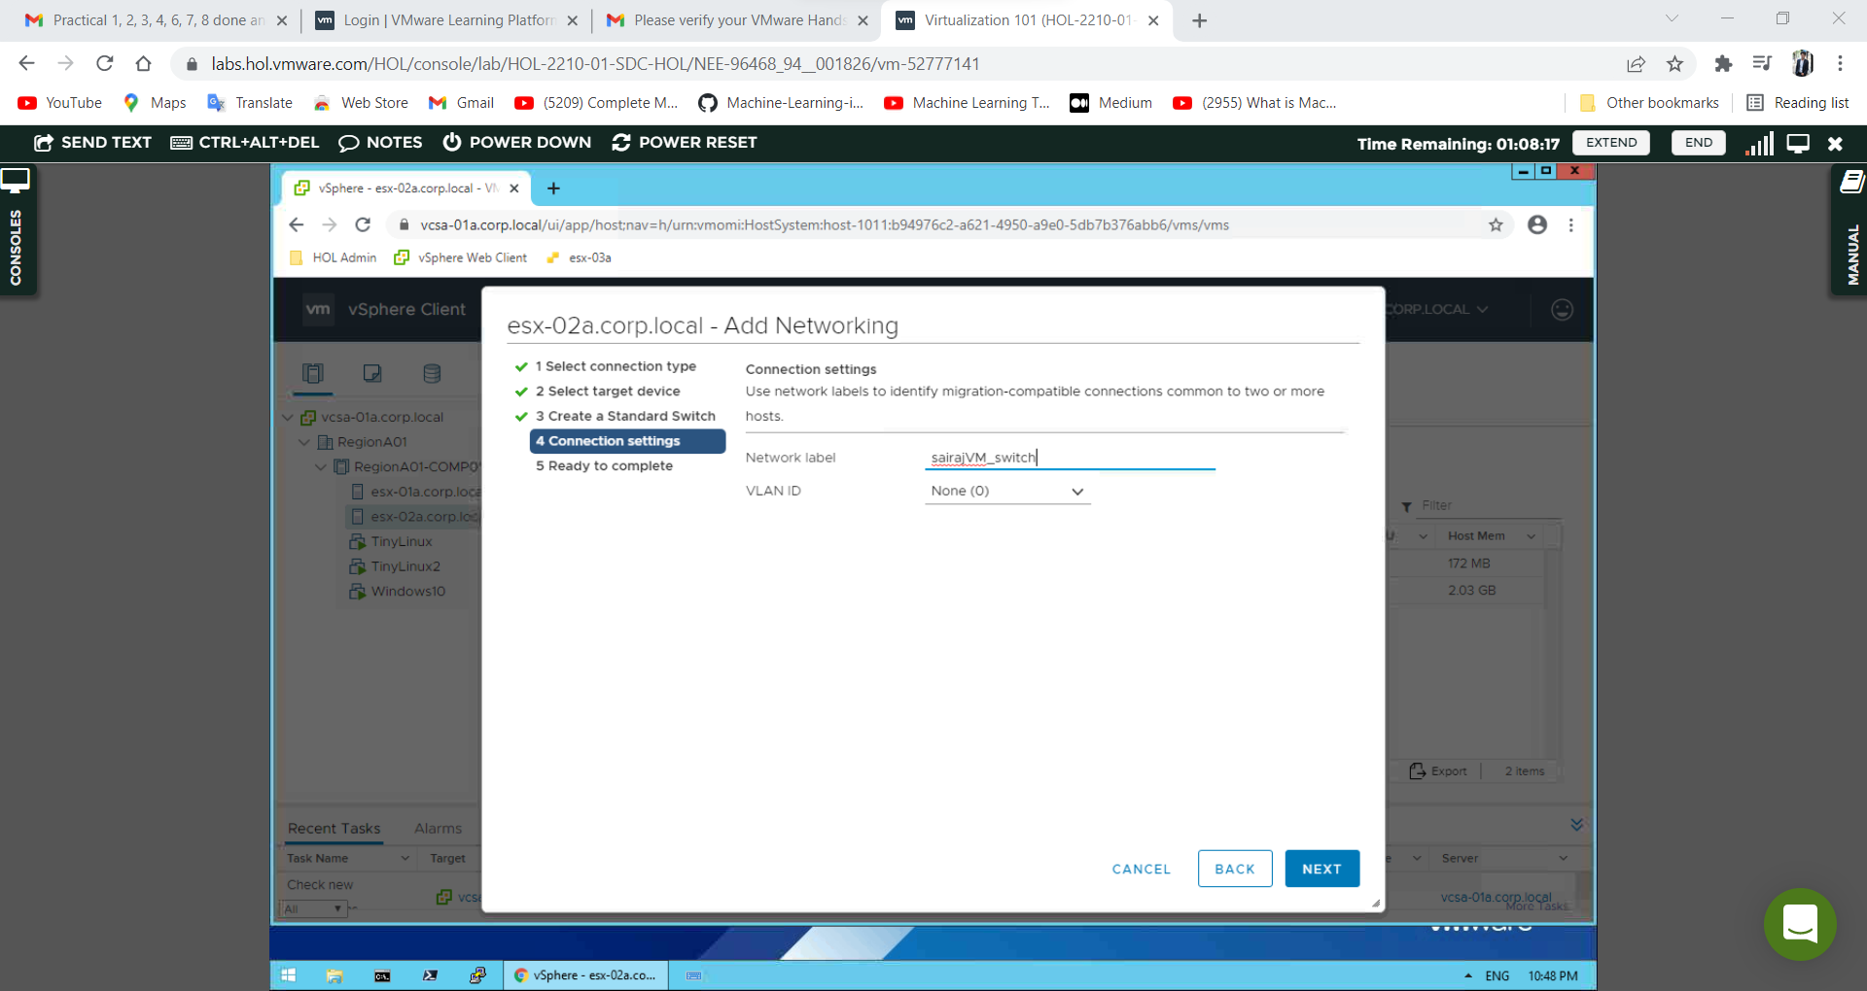

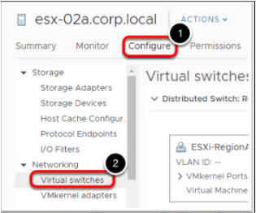Click **Configure**. Click on **Virtual Switches**.

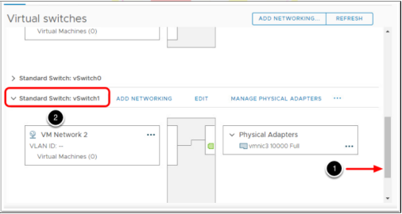Scroll down until you see Standard Switch: vSwitch1. If needed, expand the section.

You should see the above diagram showing a virtual port group (VM Network 2) that is on vSwitch1 and it is using vmnic3 as an uplink.

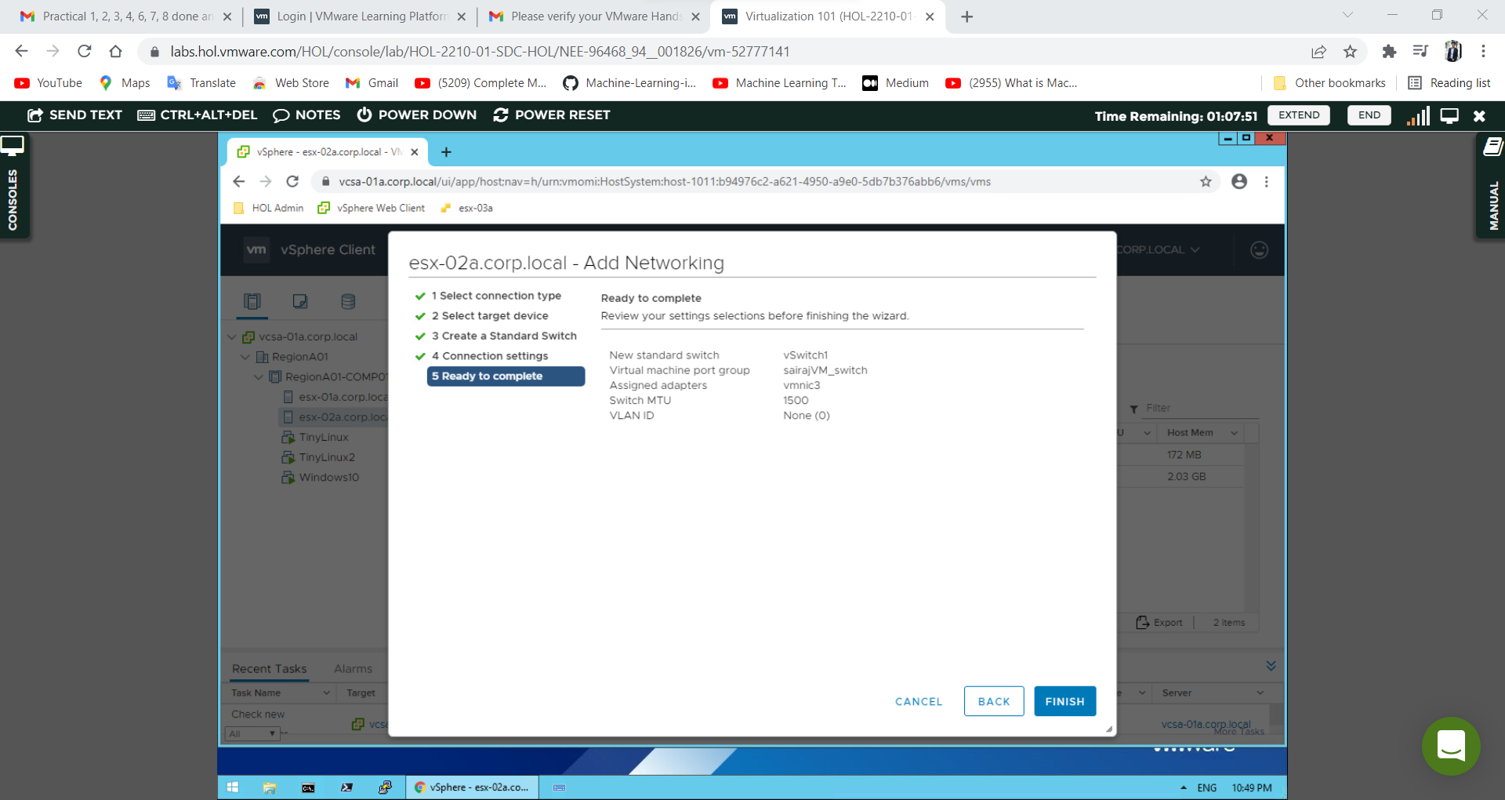

**Practical 7B**

1. **Create vSphere Distributed switch**

The VMware vSphere Distributed Switch builds on the capabilities of the vSS and simplifies management in large deployments by appearing as a single switch spanning multiple associated hosts. This allows changes to be made once and propagated to every host that is a member of the switch.

**Creating a new distributed switch.**

In the vSphere Web Client, click on RegionA01. And the navigator**, right-click the RegionA01**. Select **Distributed Switch** and then **New Distributed Switch**, This will open the New Distributed Switch wizard

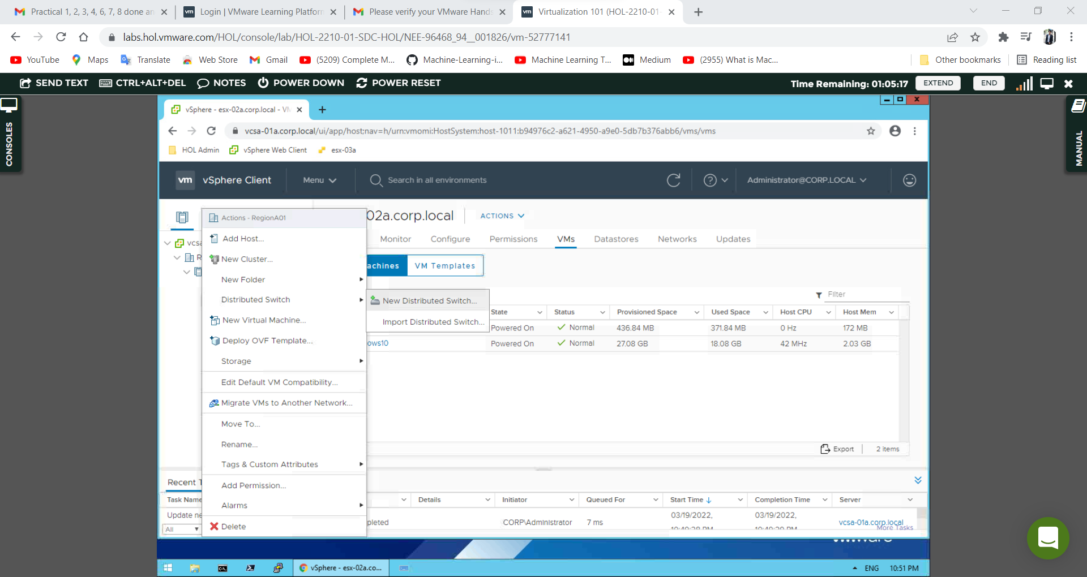

Type **Name_DS** in the Name field & Click **Next**.

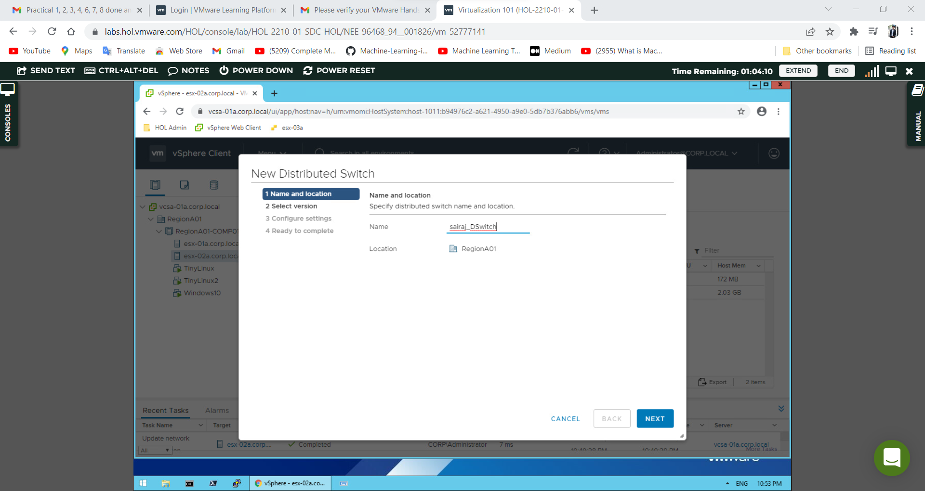

Leave the default setting of **7.0.0 - ESXi 7.0 and later** & Click **Next**.

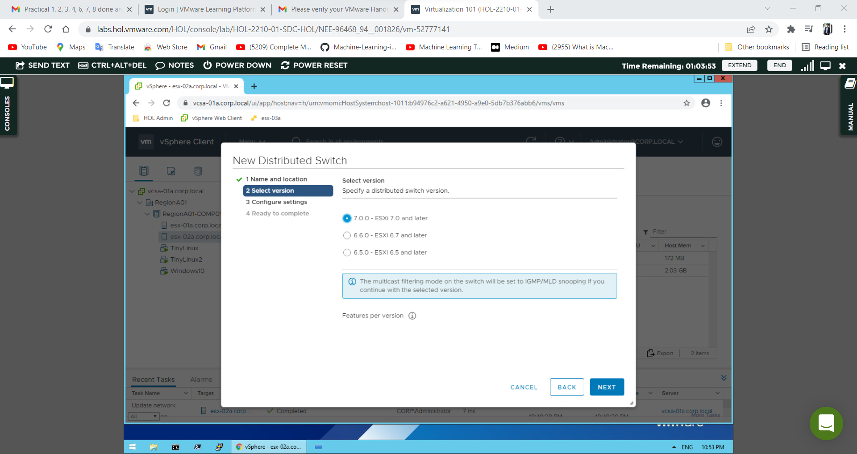

Leave the default options on the below screen and click **Next**.

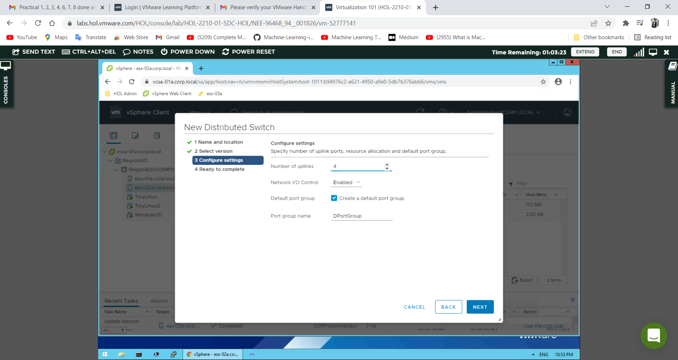

Review your settings and click **Finish**.

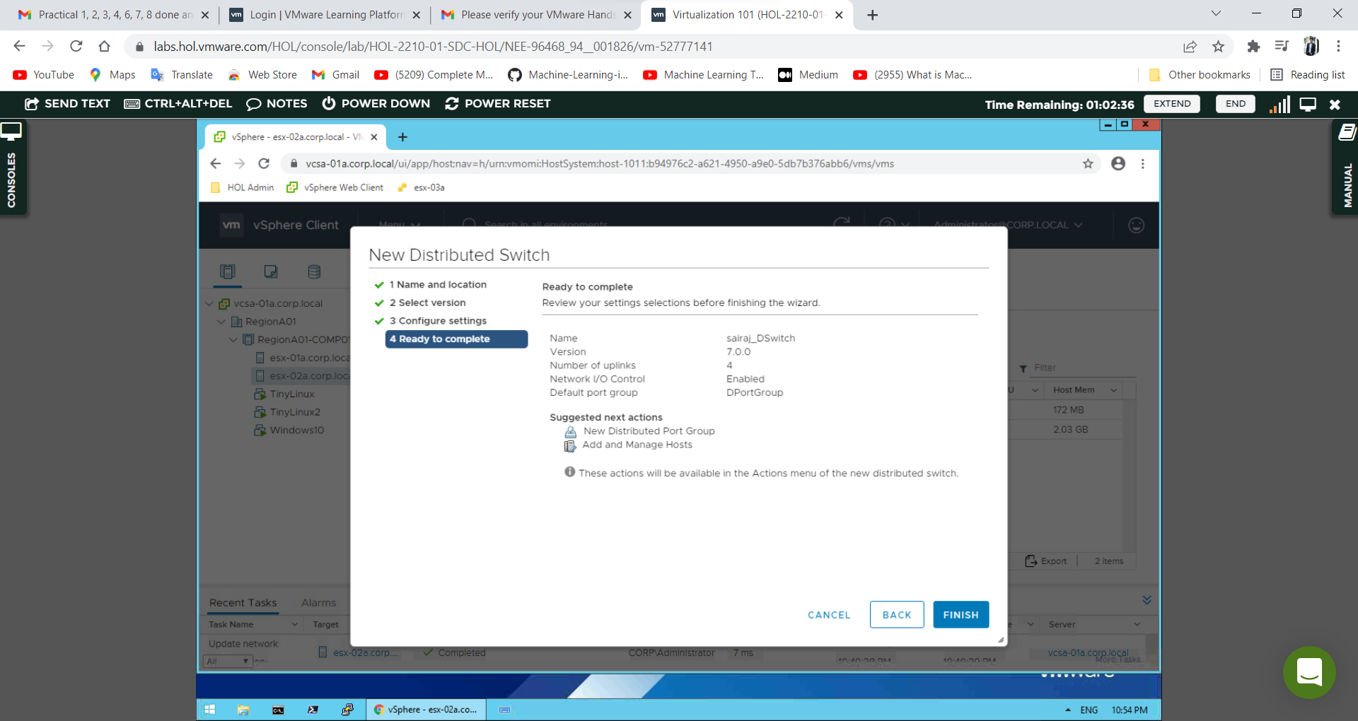

**Add Hosts to a new distributed switch.**

**Right-click** on the newly created switch, Name_DS & Select **Add and Manage Hosts**

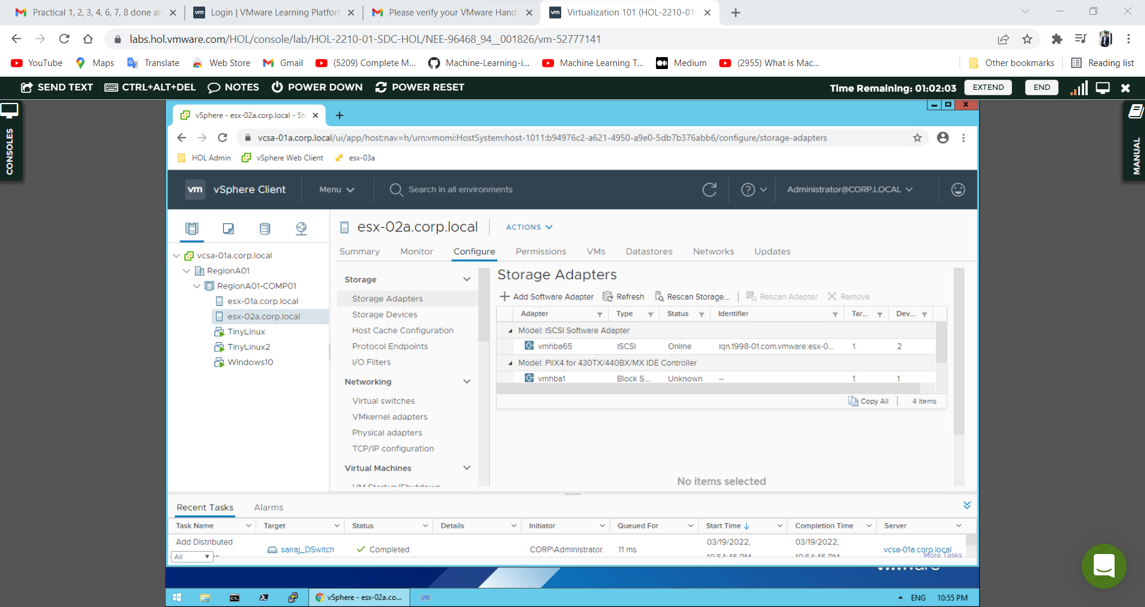

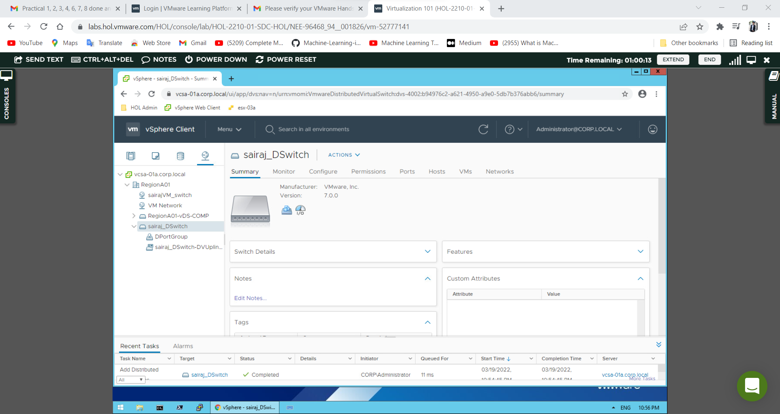

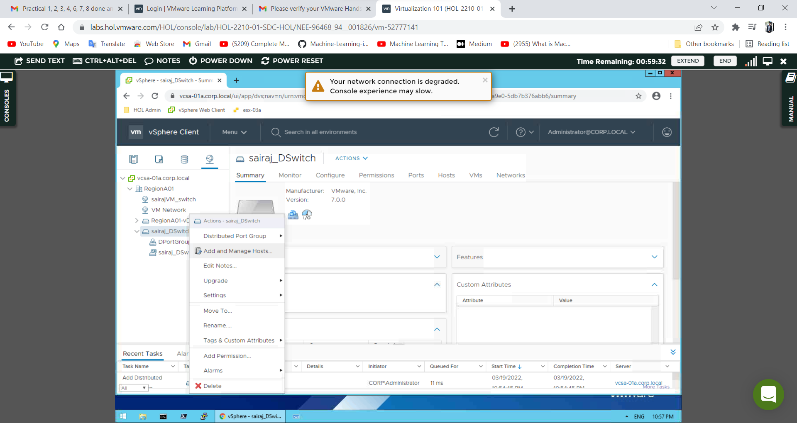

On the Select Task page, select **Add hosts** & Click **Next**.

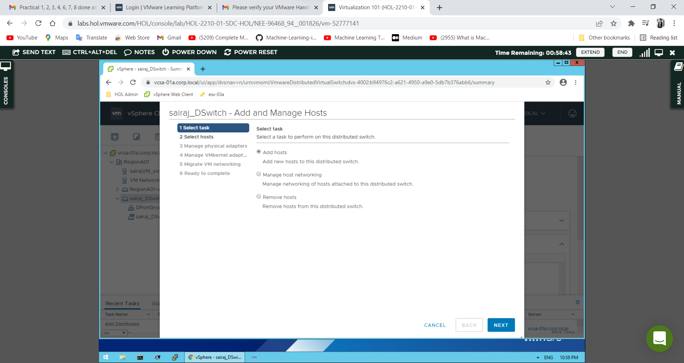

On the Select host's page, click **New hosts**.

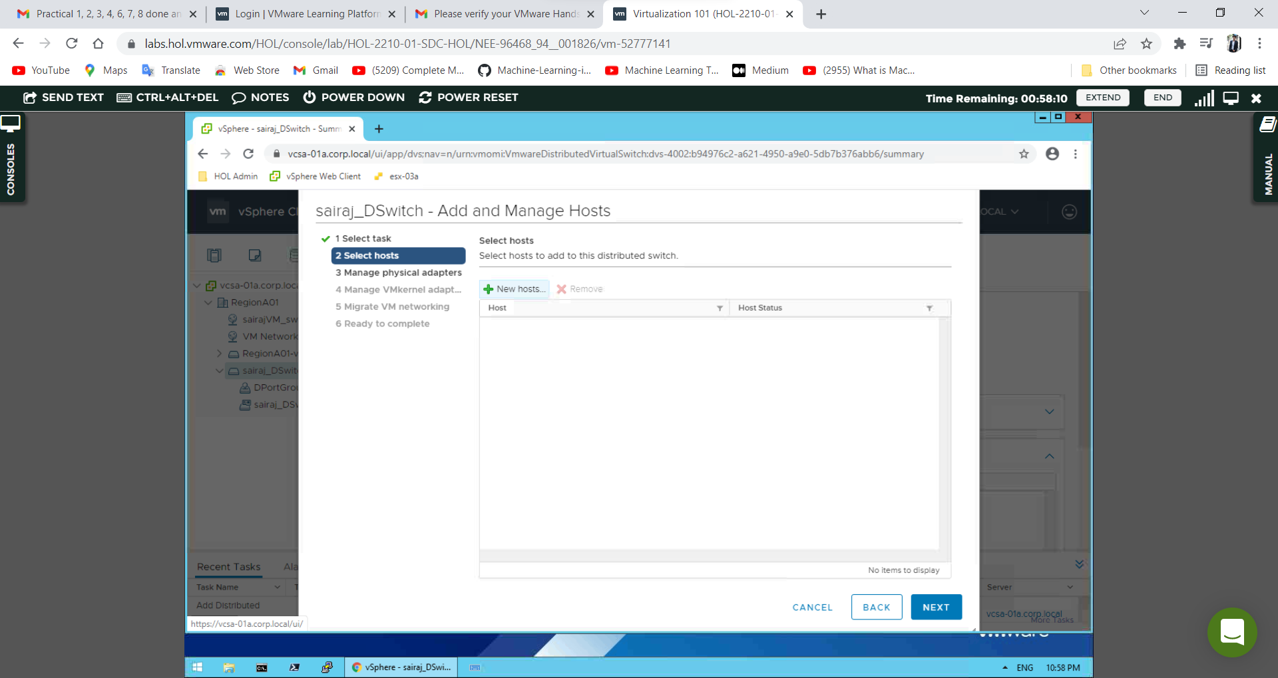

Click the **check box** on the left to **select both hosts** in the datacenter & Click **OK**.

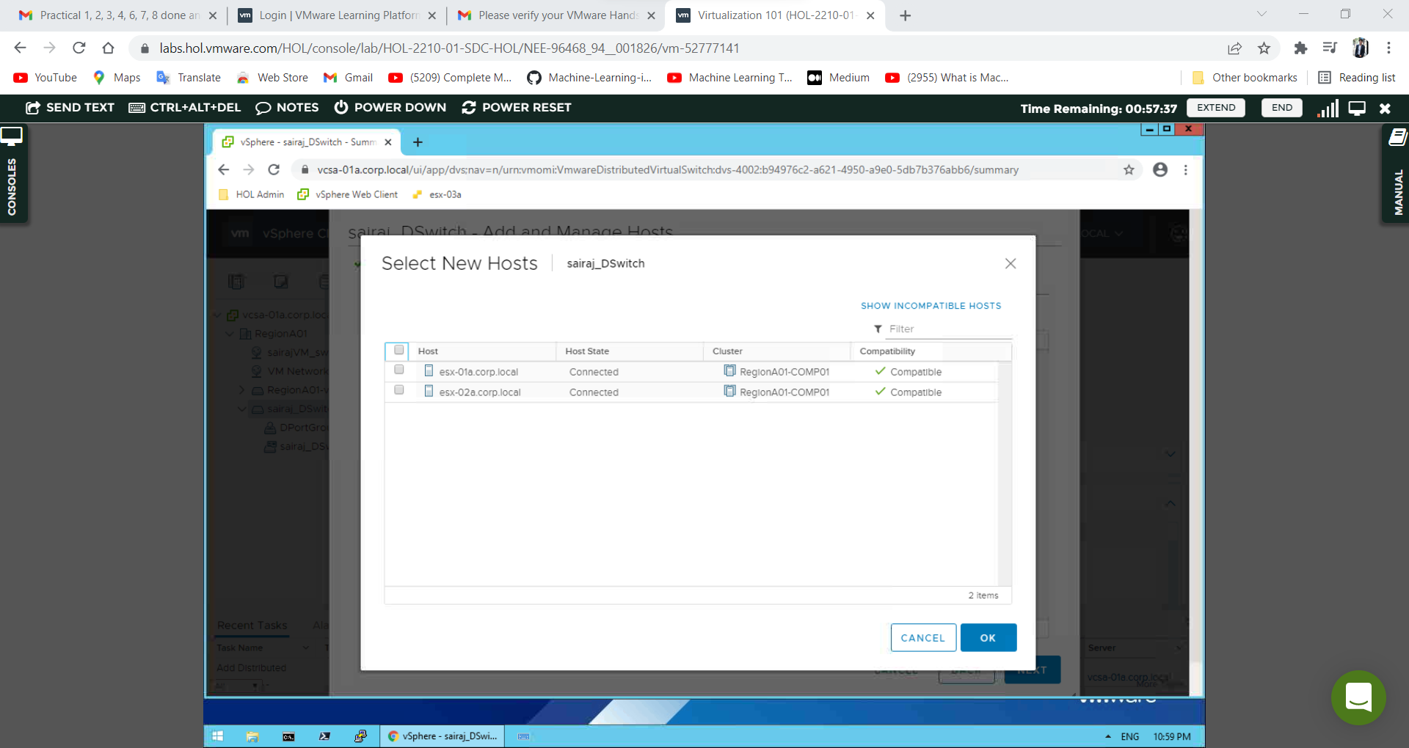

Verify the two hosts are listed, then click **Next**

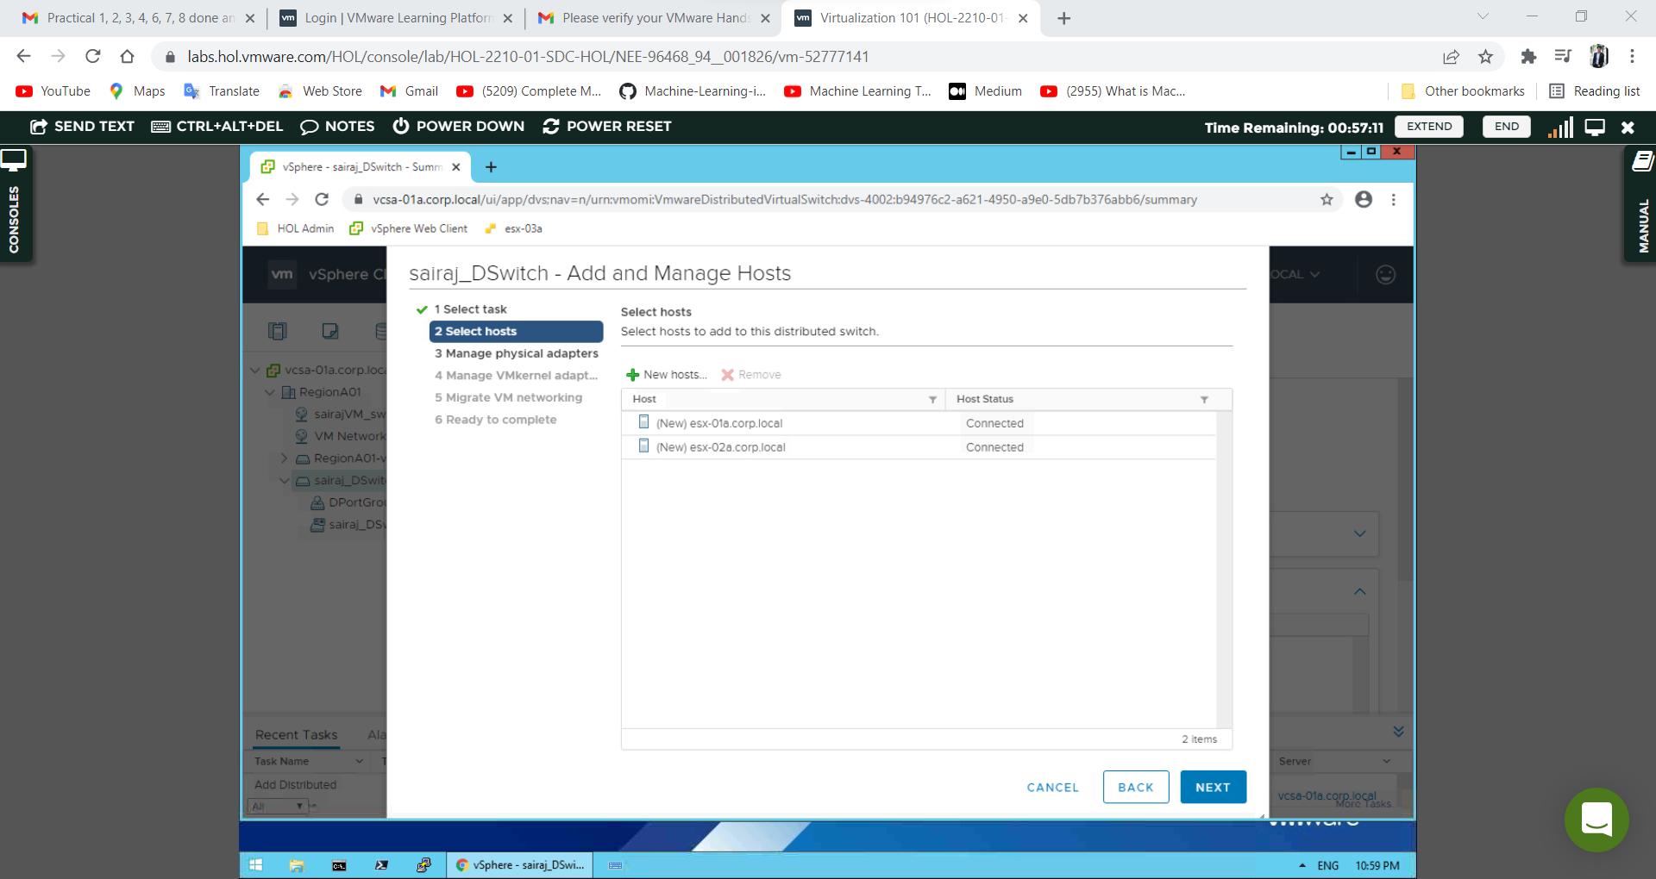

On the Manage physical network adapter’s page, we want to configure which physical NICs will be used on the distributed switch.

From the On other switches/unclaimed list, highlight vmnic3 & Click Assign uplink.

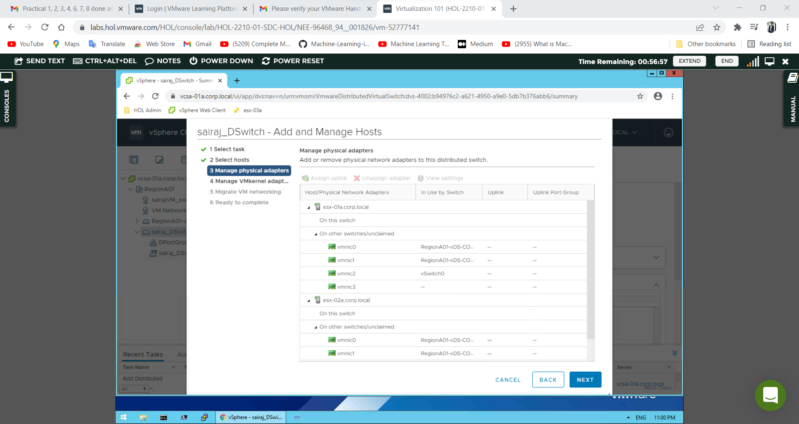

From the Select an Uplink page, **select Uplink 1**. **Check the box** next to Apply this uplink assignment to the rest of the hosts & click **OK**

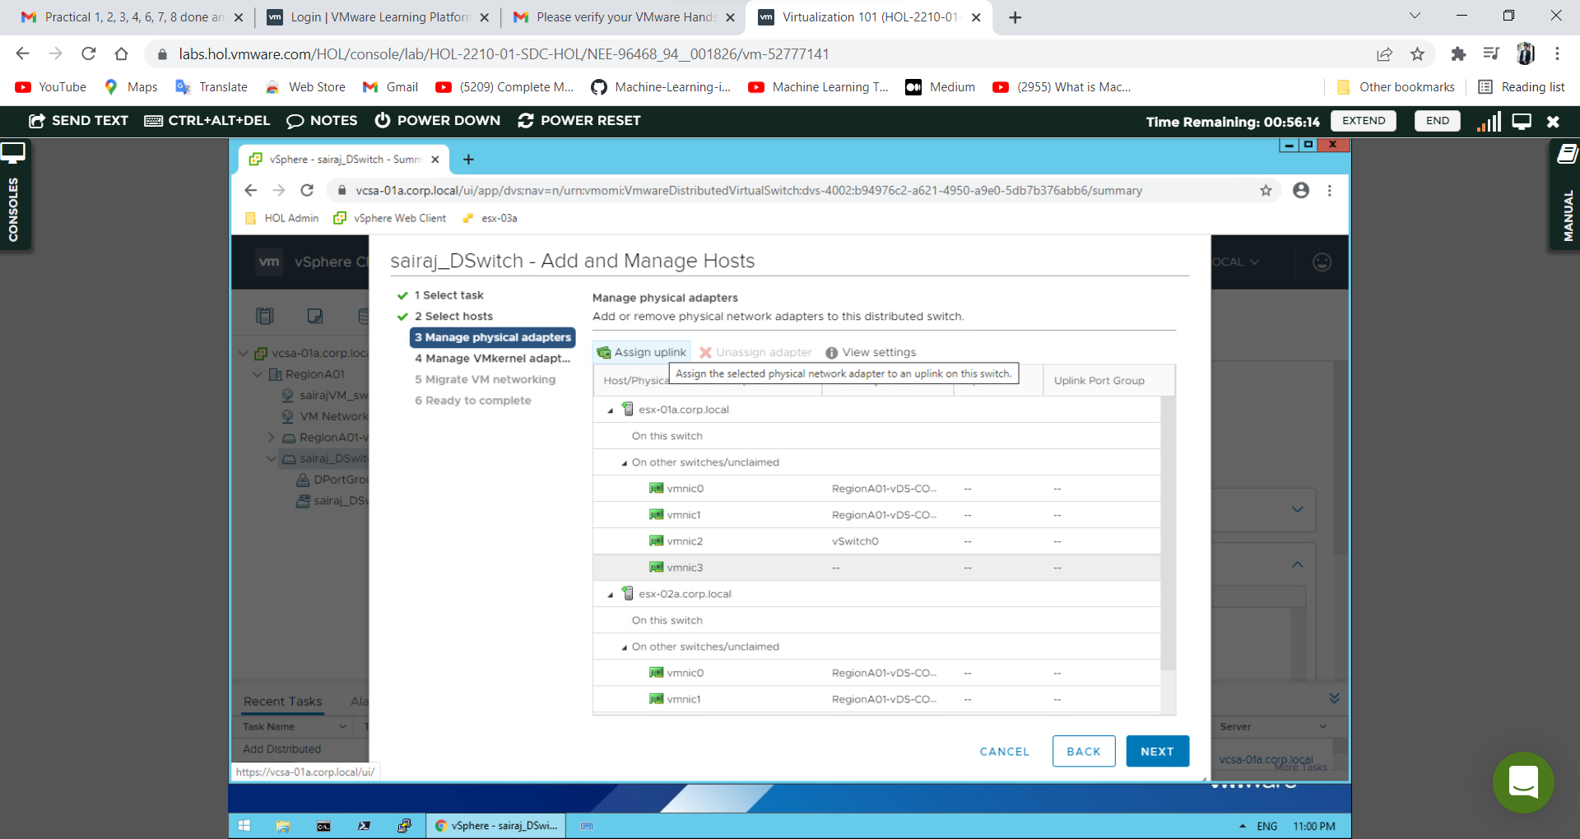

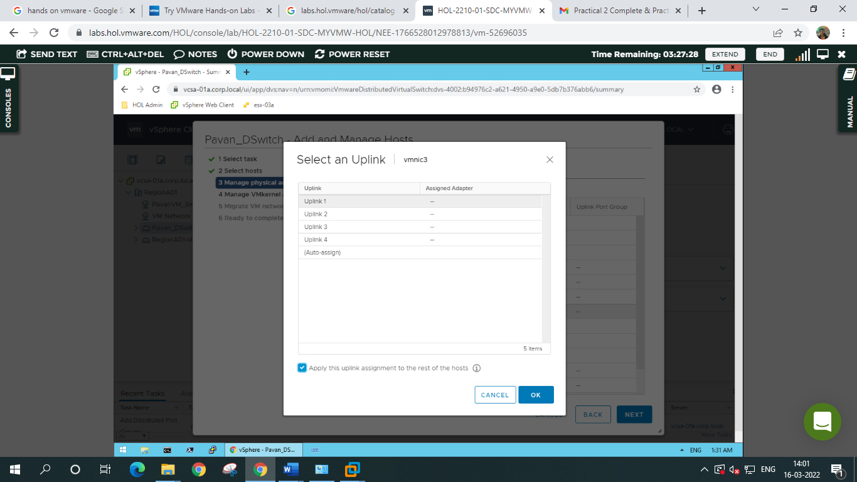

Review vmnic and uplink settings for the hosts you are adding and click **Next**

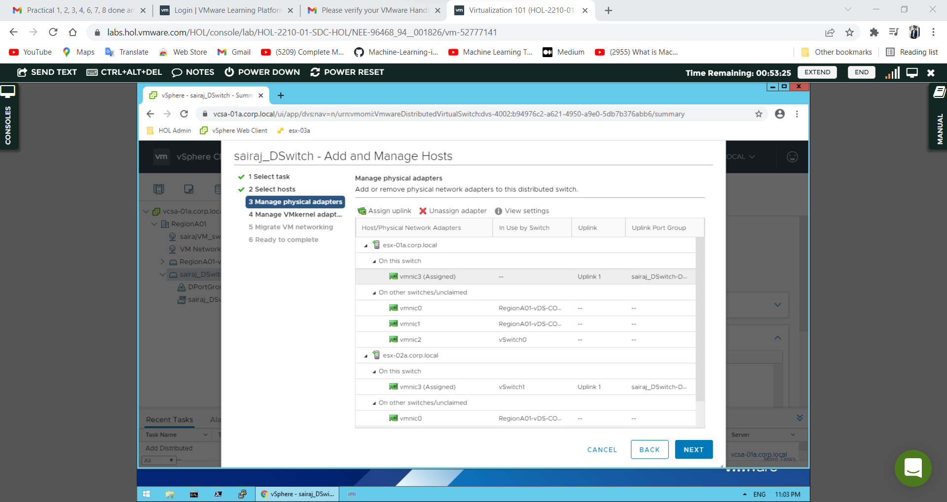

**Manage VMKernal Adapters.**

Since we will not be using this distributed switch for any VMKernel functions, click **Next**.

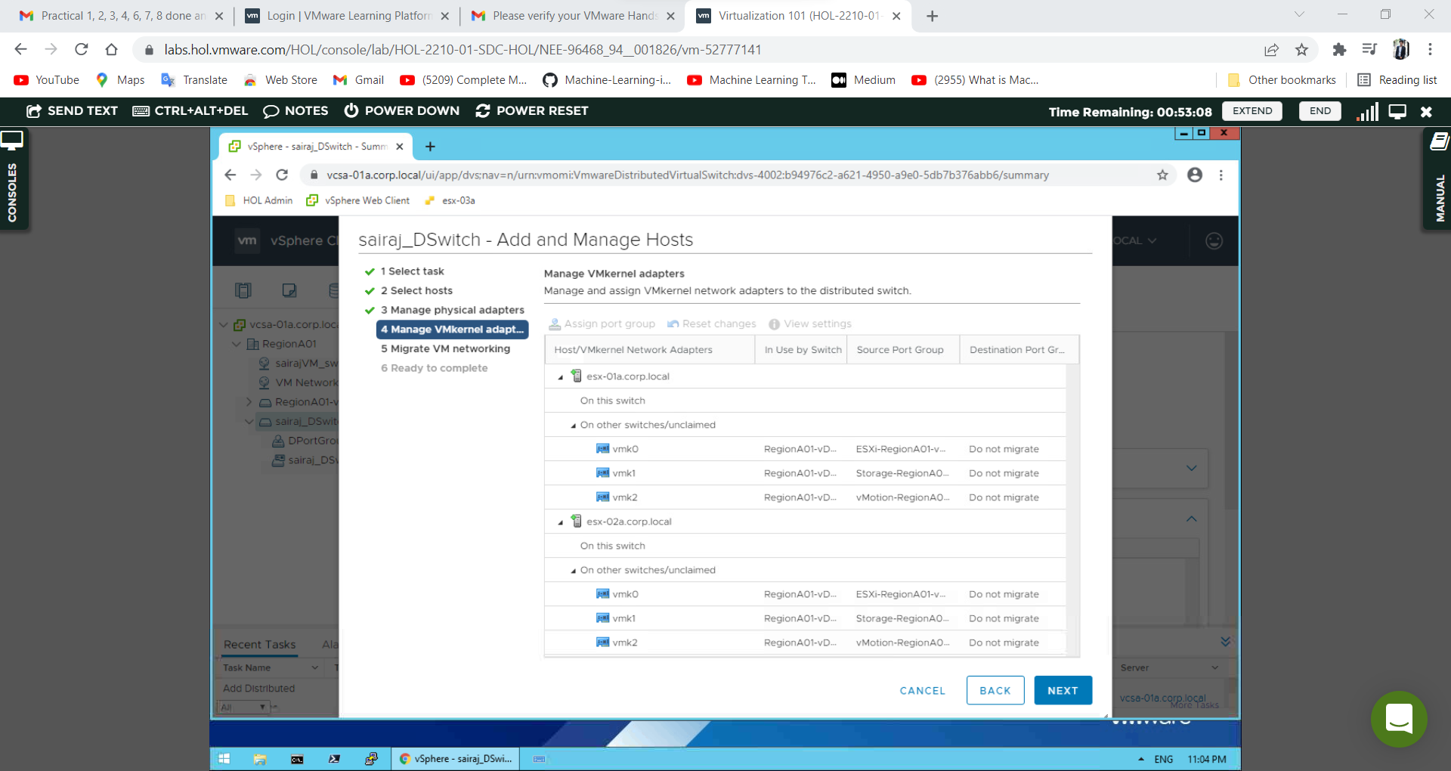

The add hosts wizard also gives us the ability to migrate VMs from one distributed switch to another on this page. While this action can be done here. Click **Next**

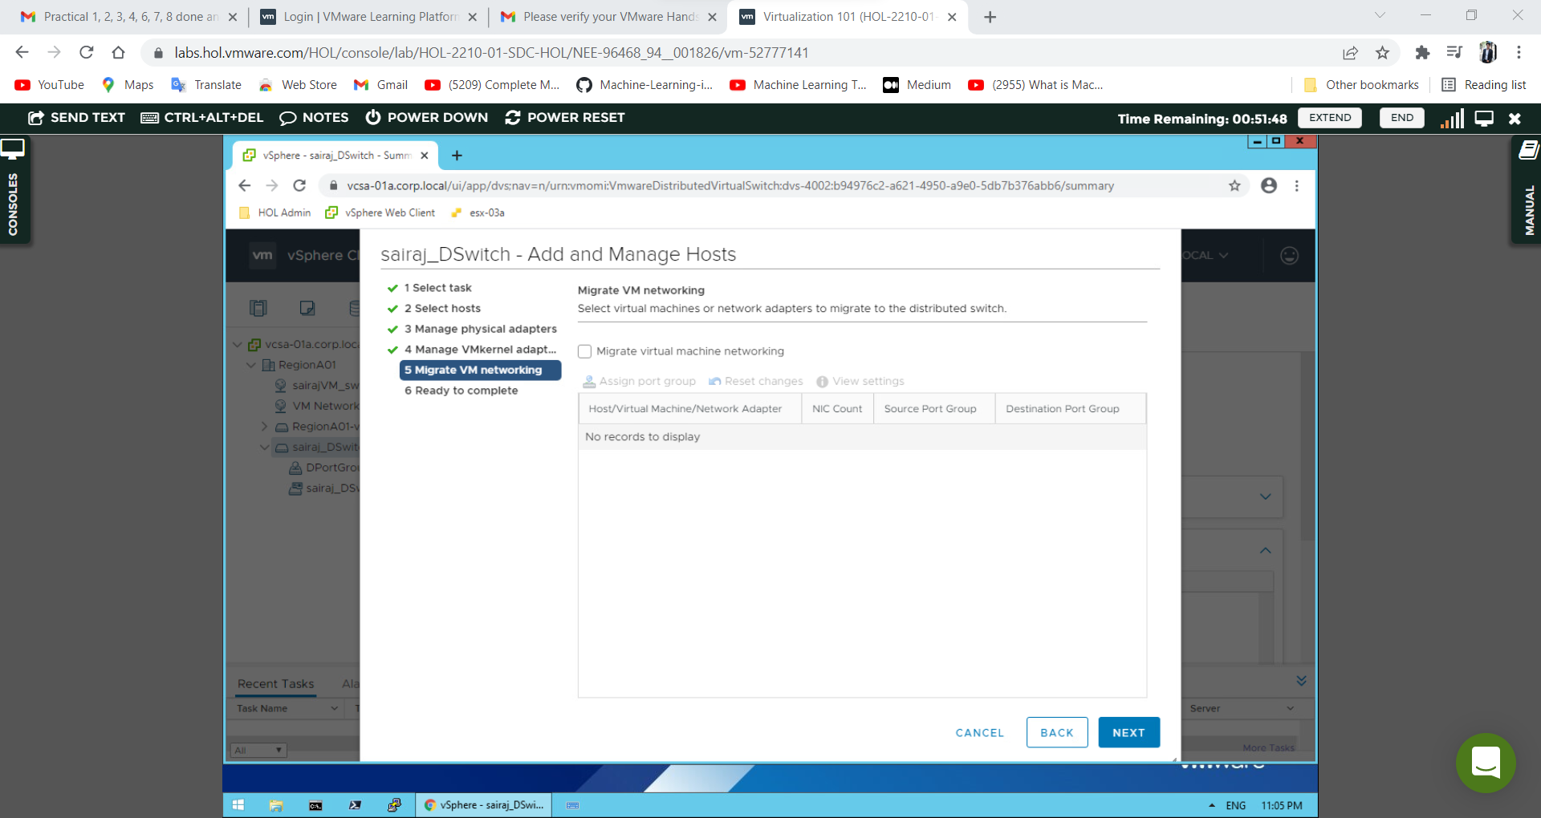

On the Ready to complete page, click **Finish**

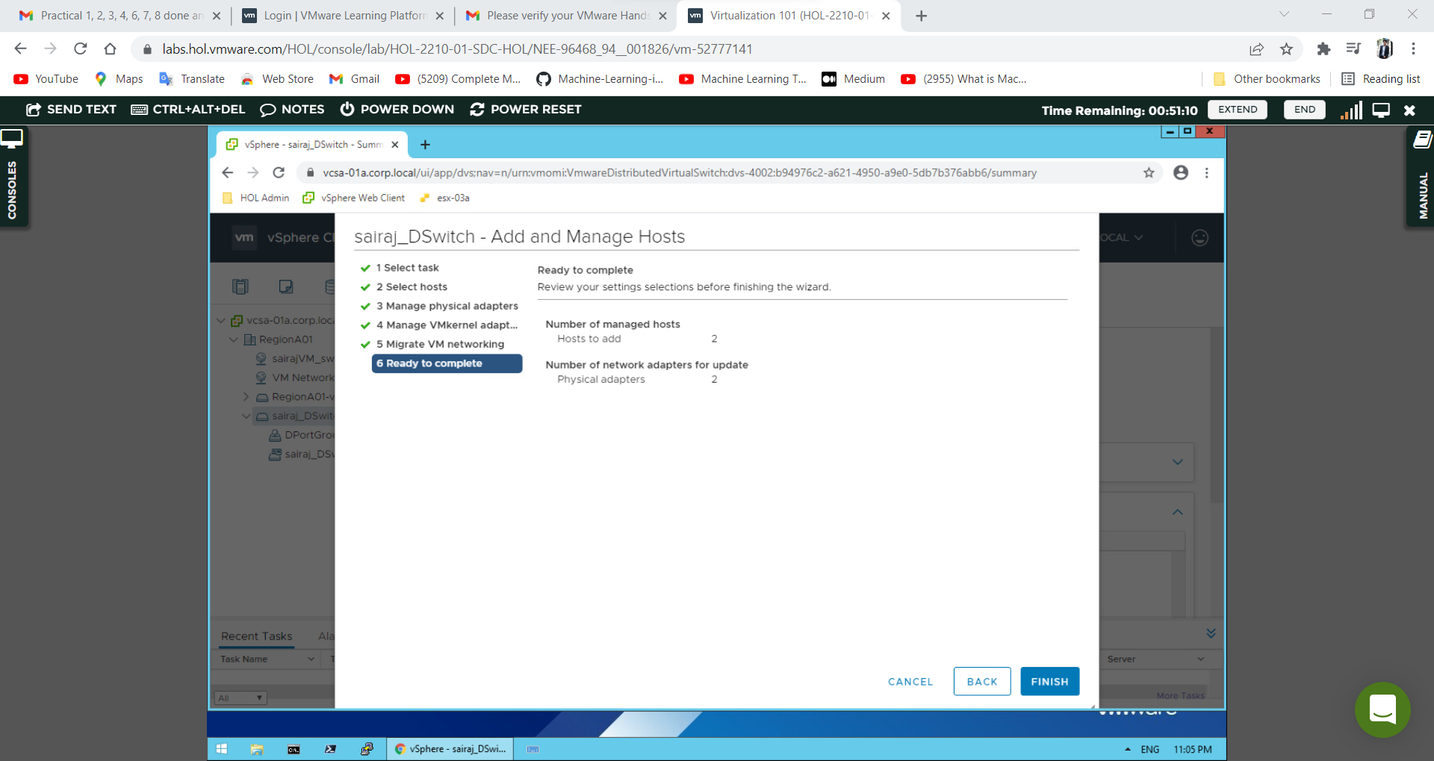

Click on the Hosts tab to see the newly connected hosts

